IT 451. Hands-on exercises.
Class work/Homework 3.

Hands-On:
- Create new Tablespace
We created a folder in the D:/app/Dana-2006/
called “Brownie”
( whole path name: D:/app/Dana-2006/Brownie )
by desktop directories & folders.
Then in SQLPLUS:

ALTER SYSTEM SET
DB_CREATEFILE_DEST= ‘D:/APP/Dana-2006/Brownie/’ SCOPE=BOTH;

CREATE TABLESPACE Brownie;
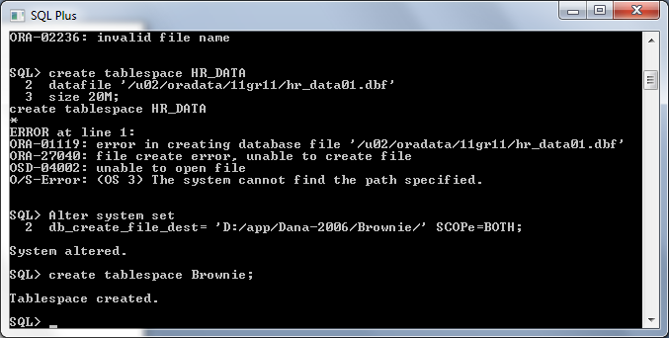

Here is the file that was created by SQLPLUS:

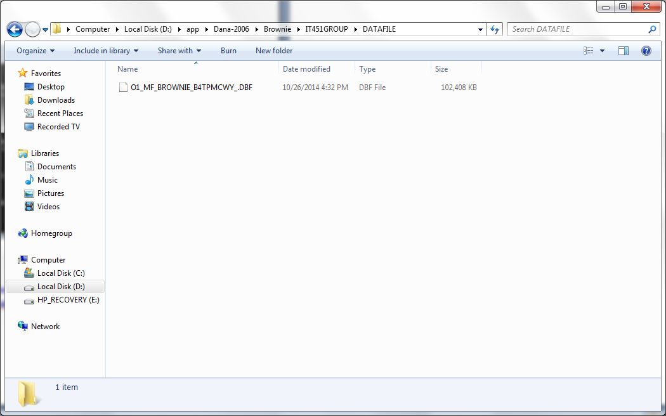

- Rename and drop Tablespace
CREATE TABLESPACE Brownie_2;

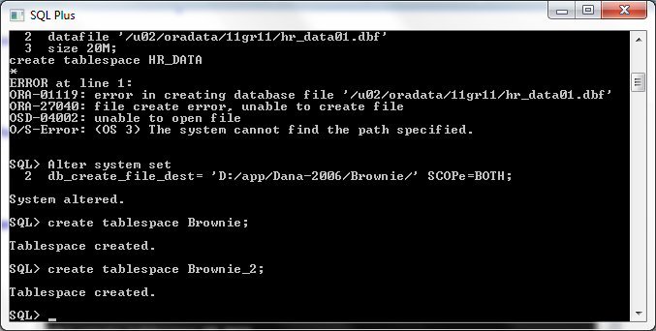

DROP TABLESPACE Brownie_2;

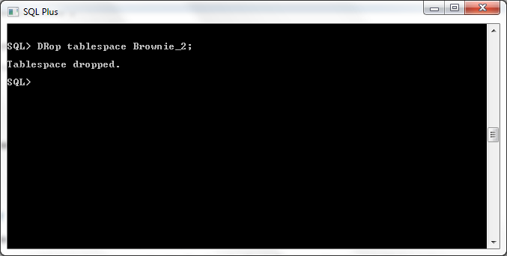

ALTER SYSTEM SET
DB_CREATE_FILE_DEST= ‘D:/app/Dana-2006/Brownie3/’ SCOPE=BOTH;
CREATE TABLESPACE Brownie3;
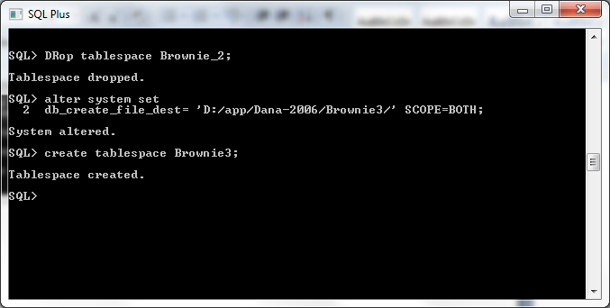

ALTER TABLESPACE Brownie3 rename TO Brownie4;
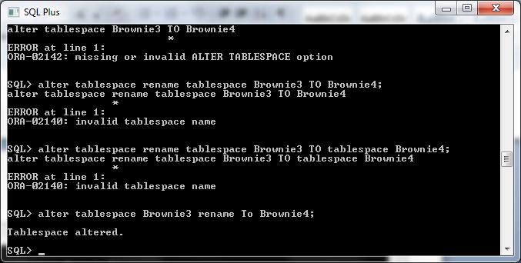

- Add data file to tablespace

ALTER TABLESPACE Brownie4 ADD DATAFILE
‘D:/app/Dana-2006/Brownie401.dbf’ SIZE 20M;

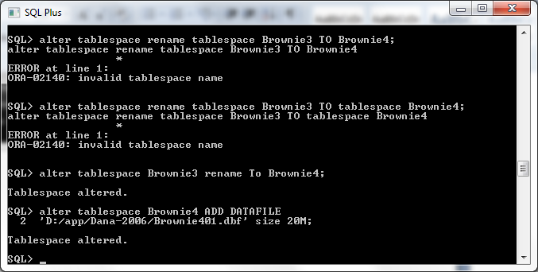

- Rename a data file
You need to take the table space offline:

ALTER TABLESPACE Brownie OFFLINE;
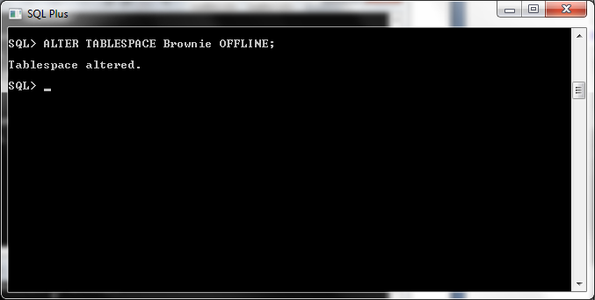

We changed BROWNIE01.DBF file to be renamed to BROWNIE100.DBF file by right clicking the file and selecting the rename option. We changed the file name here first before we changed the file name in SQL PLUS.
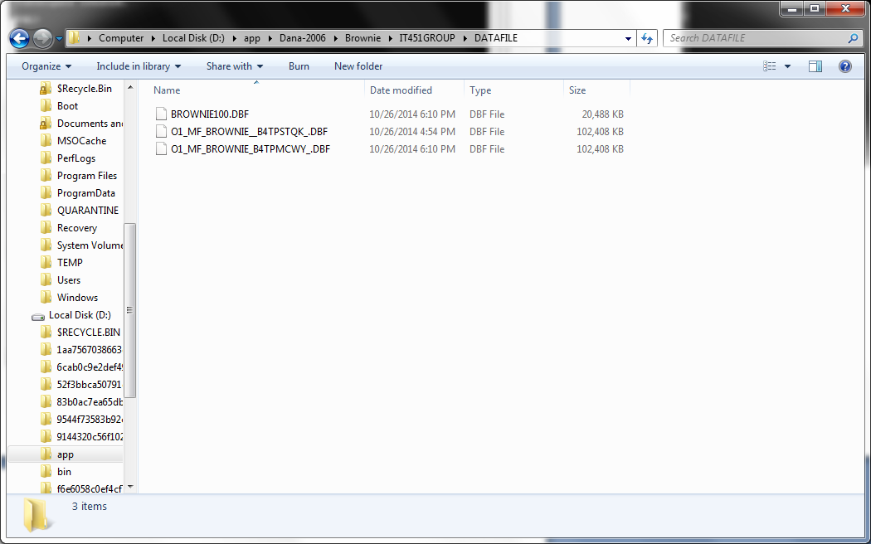

ALTER TABLESPACE Brownie RENAME DATAFILE
‘D:/app/Dana-2006/Brownie/IT451Group/DATAFILE/BROWNIE01.DBF’ TO
‘D:/app/Dana-2006/Brownie/IT451Group/DATAFILE/BROWNIE100.DBF’;

ALTER TABLESPACE Brownie ONLINE;

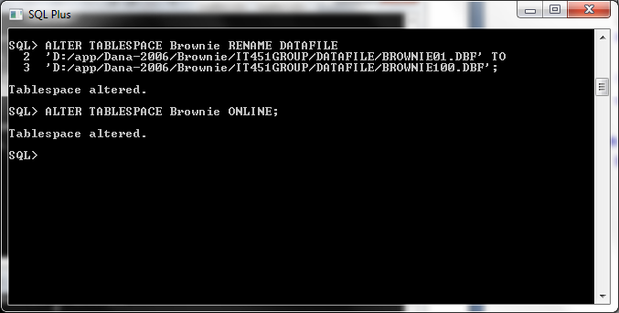

- Create tables, indexes and constraints using storage clause
CREATE TABLE Dog(
Pet_Name VARCHAR 2 (15),
Owner_Fname VARCHAR2 (15),
Owner_Lname VARCHAR2 (15),
Owner_Phone NUMBER,
Bredd VARCHAR2 (15),
Pet_Date_Of_Birth DATE,
Owner_Email VARCHAR2 (20)
)
TABLESPACE Brownie
STORAGE(INITIAL 512K NEXT 512K PCTINCREASE 0 MINEXTENTS 1 MAXEXTENTS 100 FREELISTS 1 FREELIST GROUPS 1 BUFFER_POOL KEEP);
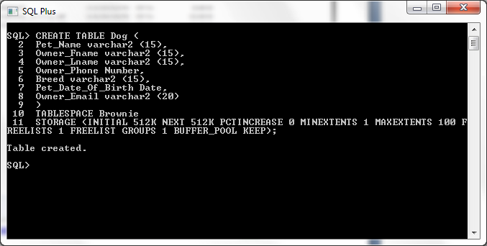

ALTER TABLE Dog ADD Dog_ID NUMBER (4);
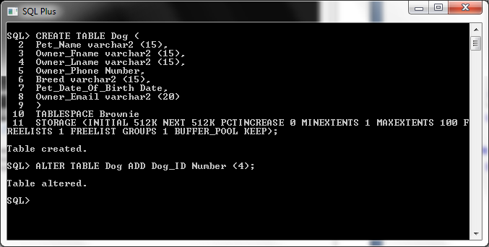

ALTER TABLE Dog
ADD CONSTRAINT PK_Dog PRIMARY KEY (Dog_ID);

CREATE UNIQUE INDEX Pet_Name ON DOG (Pet_Name)
TABLESPACE Brownie
STORAGE (INITIAL 128K NEXT 128K PCTINCREASE 0 MINEXTENTS 1
MAXEXTENTS 100 FREELISTS 1 FREELISTS GROUPS 1 BUFFER_POOL KEEP);
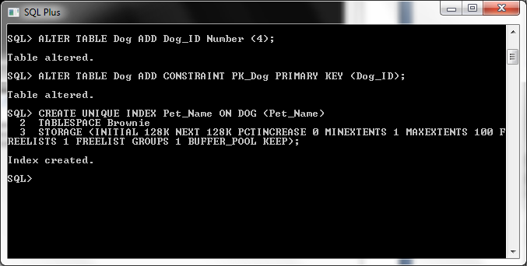

CREATE TABLE Cat (
Cat_ID Number (4),
Cat_Name VARCHAR2 (15),
Breed VARCHAR2 (15),
Cat_Date_of_Birth DATE,
Owner_Fname VARCHAR2 (15),
Owner_Lname VARCHAR2 (15),
Owner_Phone NUMBER,
Owner_Email VARCHAR2 (20),
CONSTRAINT PK_Cat PRIMARY KEY (Cat_ID)
)
TABLESPACE Brownie
STORAGE(INITIAL 512K NEXT 512K PCTINCREASE 0 MINEXTENTS 1 MAXEXTENTS 100 FREELISTS 1 FREELIST GROUPS 1 BUFFER_POOL KEEP);

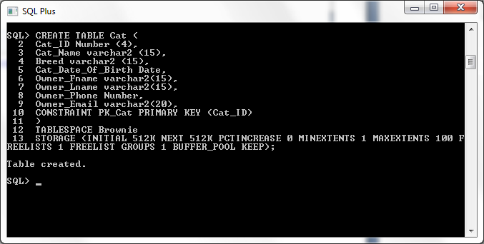

CREATE UNIQUE INDEX Cat_Name ON Cat (Cat_Name)
TABLESPACE Brownie
STORAGE (INITIAL 128K NEXT 128K PCTINCREASE 0 MINEXTENTS 1
MAXEXTENTS 100 FREELISTS 1 FREELISTS GROUPS 1 BUFFER_POOL KEEP);

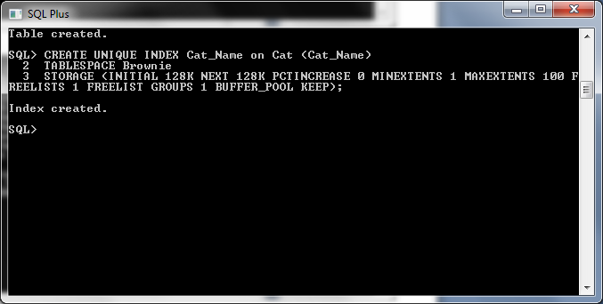
- Use Database Control to view tablespaces and storage

Table Spaces:

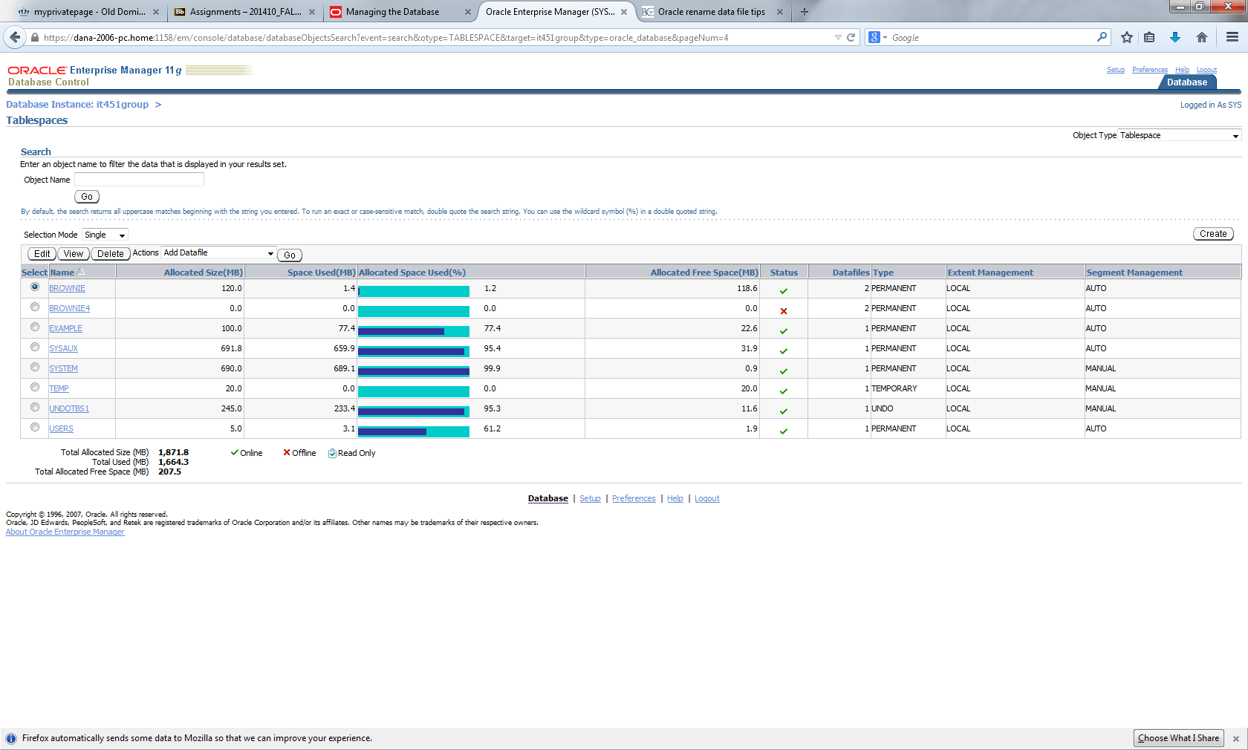
View Tablespace Brownie:
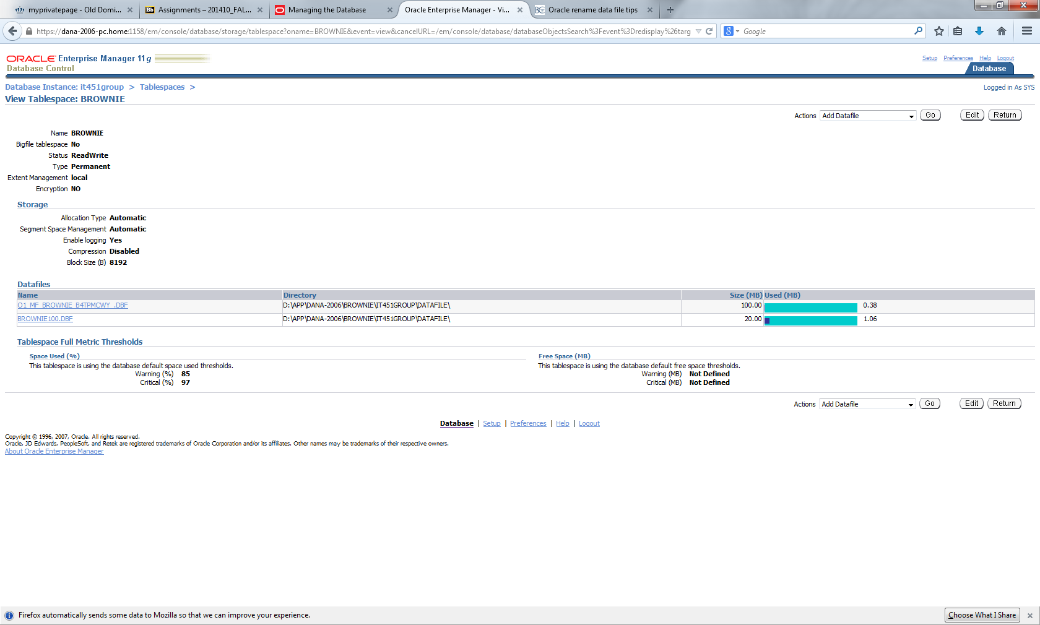
VIEW Table sys.dog :

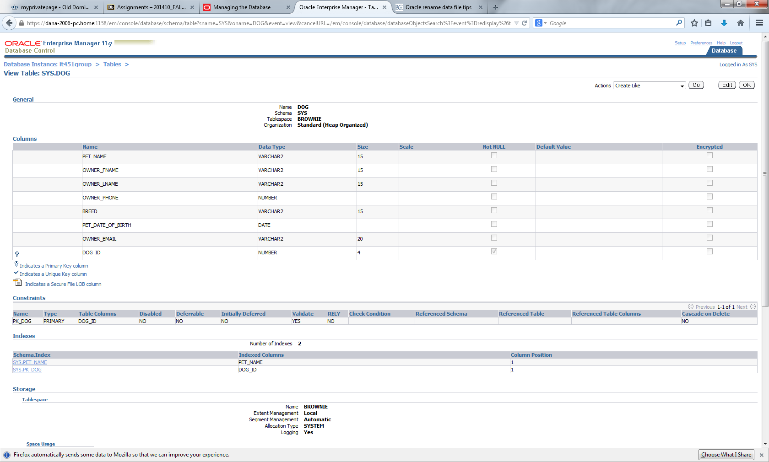

VIEW Table SYS.cat:
